**Name: laiba asif**

**Student Number: R00201303**

**Class Group: ___compdy1________________________**

**Lab 7 – Decoders and Multiplexers**

1. Complete the following truth table for a binary decoder:

# Truth Table:

|  |  |  |  |  |  |  |
| --- | --- | --- | --- | --- | --- | --- |
| A1 | A0 | D0 | D1 | D2 | D3 | Product of Terms |
| 0 | 0 | 1 | 0 | 0 | 0 | A’1.A’0 |
| 0 | 1 | 0 | 1 | 0 | 0 | A’1.A0 |
| 1 | 0 | 0 | 0 | 1 | 0 | A1.A’0 |
| 1 | 1 | 0 | 0 | 0 | 1 | A1.A0 |

2. Design a circuit which implements the binary decoder outlined in the truth table above. Verify its operation using the simulator and paste a snapshot of your circuit below.

## Circuit:

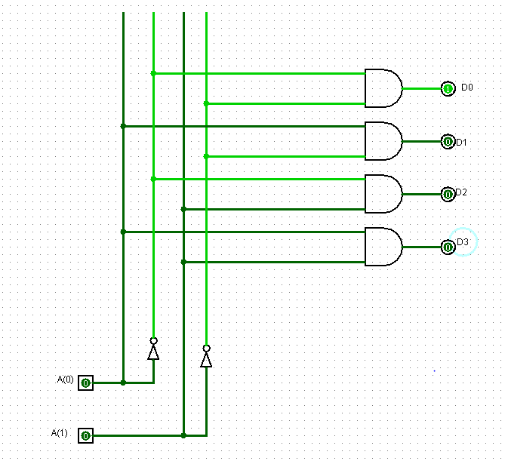

3. Draw the black box representation and complete the truth table for a 3-to-8 binary decoder:

|  |  |  |  |  |  |  |  |  |  |  |  |
| --- | --- | --- | --- | --- | --- | --- | --- | --- | --- | --- | --- |
| A0 | A1 | A2 | D0 | D1 | D2 | D3 | D4 | D5 | D6 | D7 | Output |
| 0 | 0 | 0 | 1 | 0 | 0 | 0 | 0 | 0 | 0 | 0 | A’B’C’ |
| 0 | 0 | 1 | 0 | 1 | 0 | 0 | 0 | 0 | 0 | 0 | A’B’C |
| 0 | 1 | 0 | 0 | 0 | 1 | 0 | 0 | 0 | 0 | 0 | A’BC’ |
| 0 | 1 | 1 | 0 | 0 | 0 | 1 | 0 | 0 | 0 | 0 | A’BC |
| 1 | 0 | 0 | 0 | 0 | 0 | 0 | 1 | 0 | 0 | 0 | AB’C’ |
| 1 | 0 | 1 | 0 | 0 | 0 | 0 | 0 | 1 | 0 | 0 | AB’C |
| 1 | 1 | 0 | 0 | 0 | 0 | 0 | 0 | 0 | 1 | 0 | ABC’ |
| 1 | 1 | 1 | 0 | 0 | 0 | 0 | 0 | 0 | 0 | 1 | ABC |

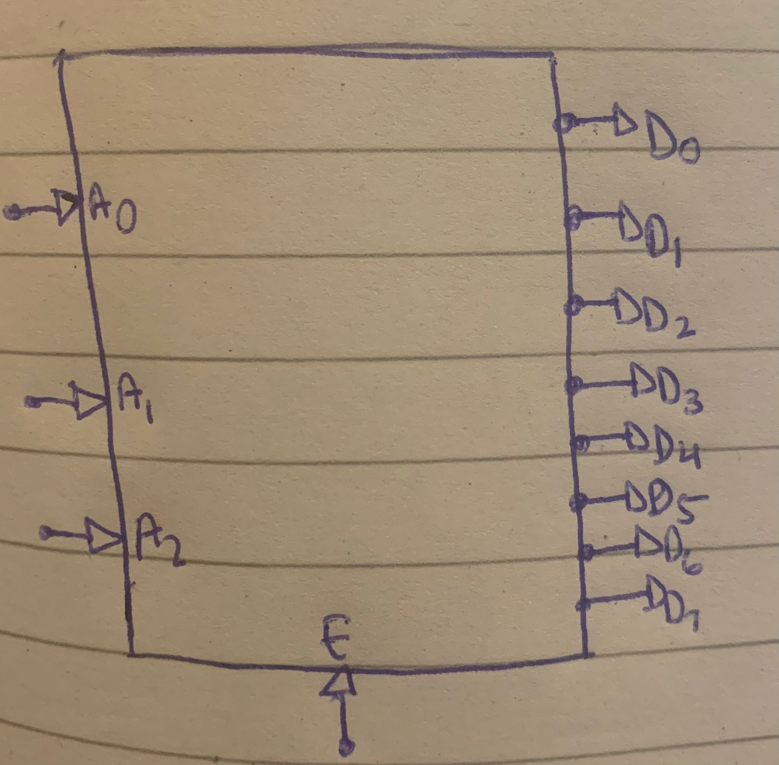

C

4. Design a circuit which implements the 3-to-8 binary decoder outlined in the truth table from Q.3. Verify its operation using the simulator and paste a snapshot of your circuit below.

**Circuit:**

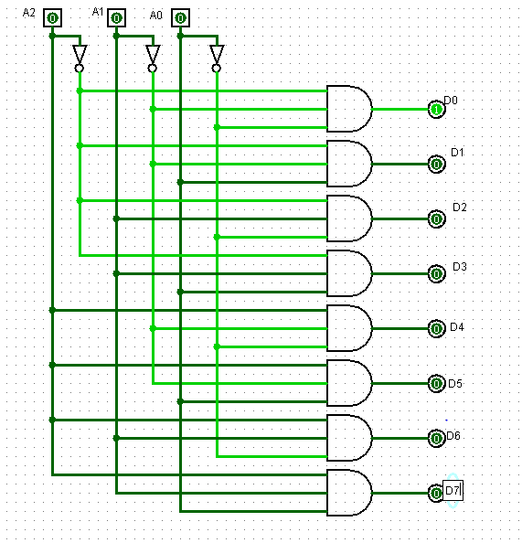

5. Complete the followingI.

## Truth Table:

|  |  |  |  |  |  |  |  |
| --- | --- | --- | --- | --- | --- | --- | --- |
| S1 | S0 | I0 | I1 | I2 | I3 | Output | Product of Terms |
| 0 | 0 | 1 | X | X | X | 0 | S’1 S’0 I0 |
| 0 | 1 | X | 1 | X | X | 0 | S’1 S0 I1 |
| 1 | 0 | X | X | 1 | X | 0 | S1 S’0 I2 |
| 1 | 1 | X | X | X | 1 | 0 | S1 S0 I3 |
| 0 | 0 | 1 | X | X | X | 1 | S’1 S’0 I0 |
| 0 | 1 | X | 1 | X | X | 1 | S’1 S0 I1 |
| 1 | 0 | X | X | 1 | X | 1 | S1 S’0 I2 |
| 1 | 1 | X | X | X | 1 | 1 | S1 S0 I3 |

6. Design a circuit which implements the multiplexer outlined in the truth table above. Verify its operation using the simulator and paste a snapshot of your circuit below.

**Circuit:**

